**SCI-AR: ENHANCE SCIENCE LEARNING  
THROUGH AUGMENTED REALITY**

# **TITLE PAGE**



**AN UNDERGRADUATE THESIS**

**Presented to**

**the faculty of the**

**College of Computer Studies**

**St. Peter’s College**

**Iligan City**

**In Partial Fulfillment**

**of the Requirements for the Degree of**

**BACHELOR OF SCIENCE IN INFORMATION TECHNOLOGY**

**CABELLO, EDWARD JR A.**

**January 2024**

# **(CERTIFICATE OF PANEL APPROVAL)**

# **ABSTRACT**

Science education can be challenging for students with specific learning difficulties, as it involves abstract concepts and requires a high level of cognitive performance. This can make it difficult for all students, regardless of whether they have specific learning difficulties or not. This study aims to help students to be more engaging on science learning and help them to easily understand science concepts using Mobile Augmented Reality Application for learning science. Moreover, using TAM theory, the study intends to assess the system's adoption and efficacy. The researchers employ a questionnaire with a 5-point Likert scale. Responses are gathered from a total of 41 respondent of Grade 5 students at Tubod Elementary School. The participants were tasked with interacting with the Mobile Augmented Reality App. Consequently, most of them agreed to use the Sci-AR following its assessment. Furthermore, the evaluation outcomes indicate that the students have a favorable attitude and positive perception towards the Sci-AR Application.

*Keywords: augmented reality,* *science augmented reality, mobile augmented reality*, *science mobile augmented reality*, *acceptance level*

# **DEDICATION**

This study is dedicated to God, to my family, and to my real friends, who supported me along the way throughout my struggles and silent battles who never left me. To all my cats who also cheer me up whenever I feel down, Thank You. They are my inspiration to keep moving forward despite the heavy blow of life. Their prayers and support will be strength until the day thy end.

# **ACKNOWLEDGEMENT**

I extend our deepest appreciation to the individuals mentioned below, whose substantial contributions greatly facilitated the completion of the study:

To my adviser, Mr. Rolan Meryll B. Montebon, for his unwavering support and guidance and inputs for the success of the study;

To the panel members, Mr. John Andy B. Genovia, Mrs. Elleiell Balisi, and to the Dean of College of Computer Studies, Mrs. Mellanie S. Gambe, MSIT, for their insightful feedback, suggestions, and advice;

To the participants for their time and assistance;

To the researchers' families who unwaveringly supported the completion of the

study;

Most importantly, to God for His direction, generosity, and wisdom.

**TABLE OF CONTENTS**

**PAGE**

TITLE PAGE i

(CERTIFICATE OF PANEL APPROVAL) ii

ABSTRACT iii

(DEDICATION) iv

ACKNOWLEDGEMENT v

LIST OF TABLES viii

LIST OF FIGURES ix

**CHAPTER**

1 INTRODUCTION

Background of the Study 1

Research Objectives 2

General Objectives 2

Specific Objectives 2

Scope and Limitations of the Study 2

Significance of the Study 4

Analytical Framework 4

The Theory Used in the Study 8

Operational Definition of Variables and Terms 9

2 REVIEW OF RELATED LITERATURE

Augmented Reality 11

Technology Acceptance Model (TAM) Theory 12

Simultaneous Localization and Mapping (SLAM) Algorithm 13

3 METHODOLOGY

Research Design 14

Physical Environment and Resources 16

Hardware 16

Software 17

Tools and Techniques to be Used in the Study 18

Use Case Diagram 18

Sequence Diagram 19

Activity Diagram 20

Research Setting 22

Research/Informants/Sample and Sample Method 22

Data Gathering Method: Instruments and Process 22

Data Analysis Method 23

Research Ethics 24

4 RESULTS AND DISCUSSIONS

Objective 1 25

Objective 2. 46

5 SUMMARY, CONCLUSIONS, AND RECOMMENDATION

Summary of Findings 49

Conclusions 49

Recommendations 49

REFERENCES 50

APPENDICES

A Letter of Approval 53

B Survey Questionnaire 54

C Data Sets 55

D Photo Documentation 59

VITA 60

CERTIFICATE OF AUTHENTIC AUTHORSHIP 61

# **LIST OF TABLES**

**Table Page**

1 Use Case Diagram Description Table 19

2 Sci-AR Entity Relationship Diagram 22

3 Likert Scale Used in the Questionnaire 23

4 Tubod Elementary School Pupils 46

5 Student’s Acceptance Level 47

# **LIST OF FIGURES**

**Figure Page**

1 Augmented Reality Workflow Diagram 4

2 Sci-AR – Getting 3D Model from database 5

3 Sci-AR – Creating/Writing 6

4 Sci-AR – Editing existing notes 6

5 Sci-AR – Deleting existing notes 7

6 Technology Acceptance Model 8

7 Agile Methodology 14

8 Use Case Diagram 18

9 Sequence Diagram 20

10 Activity Diagram 21

11 Note Creation 25

12 Note creation code 26

13 View list of created notes 27

14 View list of created notes code 29

15 Edit created notes 30

16 Edit created notes code 31

17 View and Delete created notes 32

18 View created notes code 33

19 Delete created notes code 34

20 Projecting 3D Model using Augmented Reality 35

21 Projecting 3D Model using Augmented Reality Code 38

22 3D Model Notes 39

23 3D Model Notes Code 43

24 3D Model List 44

25 3D Model List Code 45

26 Respondents trying out Sci-AR 59

27 The researcher (Left) with the student’s teacher (Right) 59

# **LIST OF APPENDICES**

**Appendix Page**

A Letter of Approval 53

B Survey Questionnaire 54

C Data Sets 55

D Photo Documentation 59

**CHAPTER 1**

**INTRODUCTION**

This chapter will introduce the issue addressed by the study, as well as its proposed solution. It will also describe the functions of the system, identify its limitations, and discuss the significance of the research.

**Background of the Study**

Students with specific learning difficulties often struggle with learning science, as it encompasses abstract concepts and demands a high level of cognitive performance, making it challenging for all students, regardless of whether they have specific learning difficulties or not. Similarly, primary school students struggle with fully grasping complex and abstract ideas, such as basic concepts in astronomy. The abstract nature of these concepts hinders their comprehension, leading to a negative impact on their overall attitude towards the subject (Sahin and Yilmaz, 2020); (Turan and Atila, 2021).

Additionally, Sahin and Yilmaz (2020) noted that to address these challenges, it is crucial to enhance the understanding of abstract scientific concepts by incorporating visual aids in the teaching process. Moreover, one of the emerging technologies that is still new to education but shows great potential is Augmented Reality (AR). Augmented Reality (AR) is an emerging technology that finds applications in diverse educational contexts (Jessup et al., 2019). Liono et al., (2020) also noted that using visualization is considered one of the most effective learning methods as it makes the subject more engaging and helps students comprehend the concepts better.

The mobile application will run on Android Operating System and will only support later version of Android as long as it also supports Augmented Reality. The researcher uses Unity3D and ARFoundation/ARCore in the development of the mobile application. Unity3D is a cross-platform game engine used to develop video games for computers, consoles, mobile devices, and websites. It provides tools for creating and manipulating 3D graphics, physics simulations, animations, and user interfaces. ARFoundation/ARCore is a platform developed by Google for building Augmented Reality (AR) experiences on mobile devices. It uses a combination of sensors and the SLAM (Simultaneous Localization and Mapping) algorithm to enable devices to understand and interpret the environment around them, and then overlay virtual objects on top of the real world.

The Technology Acceptance Model will be the theory to create the system. The approach consists of four main factors: perceived ease of use (PEU), perceived usefulness (PU), attitudes toward technology use (ATU), and behavioral intention (BI). Together, these four main factors help to predict a user's intention to use a technology.

Lastly, this research paper presents a distinctive method to help students' increase motivation and gaining their confidence in learning science, without eliminating the traditional teaching approach.

**Research Objectives**

In this section, the researcher identifies both broad and particular aims.

**General Objectives**

The primary goal of the study is to develop a Mobile Augmented Reality Application for Grade 5 Students of Tubod Elementary School in Iligan City. This study used the Technology Acceptance Model to evaluate the Mobile Augmented Reality Application and Specifically, this study aims to:

1. Develop a Mobile Augmented Reality for Science Learning, which includes the following functionalities:
   1. Animated 3D models
   2. Informative 3D models
   3. Note keeper
2. Assess the effectiveness and acceptance of the Mobile Augmented Reality Application by students through the utilization of the Technology Acceptance Model.

**Scope and Limitation**

The main emphasis of the research is to develop a Mobile Augmented Reality Application for learning science that will help students to be more engaging on science learning and help them to easily understand science concepts, which will be conducted within Tubod Elementary School, Tubod, Iligan City, specifically for Grade 5 Students.

The researcher's focus is solely on creating a Mobile Augmented Reality Application, which may include the functionalities mentioned in the previous section of the study. Additionally, the researcher utilized ARFoundation/ARCore to implement Augmented Reality and enable the superimposition of 3D objects or models onto the augmented world.

The algorithm, SLAM, which is already included inside ARCore SDK and Unity3D a game engine, will be the in charge to overlay the 3D models and determines the device position and orientation.

Moreover, in evaluating the application's usability and potential for adoption, the study will utilize the Technology Acceptance Model (TAM). The TAM variables to be assessed include:

**Perceived Usefulness (PU):** Perceived Usefulness is a measure of the user's perception of how beneficial the Mobile Augmented Reality Application will be in enhancing their science learning experience. It gauges the extent to which students believe that using the application will improve their understanding of science concepts and engagement with the subject matter (Davis, 1989).

**Perceived Ease of Use (PEOU):** Perceived Ease of Use refers to the user's perception of how easy it is to use the Mobile Augmented Reality Application. It evaluates the simplicity and user-friendliness of the application and how intuitively students can navigate and interact with the augmented content (Davis, 1989).

**Attitude towards Using (ATU):** Attitude towards Using measures the student's overall positive or negative feelings and evaluations regarding the utilization of the Mobile Augmented Reality Application. It is influenced by the perceived usefulness and perceived ease of use and significantly impacts the intention to use the application (Davis, 1989).

These variables will be assessed within the context of the Grade 5 students at Tubod Elementary School, Iligan City, to determine the potential impact and acceptance of the Mobile Augmented Reality Application for science learning. The assessment will consider how these variables influence the students' acceptance and intention to use the application, which, in turn, affects their engagement and understanding of science concepts.

Other platforms, devices and documentation tools are not included in the study. Moreover, the application lacks three key functionalities. First, it does not offer the capability to create lessons. Second, it does not provide the option to generate quizzes within the application. Third, the app operates without requiring users to create accounts, thus eliminating the need for an account creation feature.

**Significance of the Study**

This research will be valuable for individuals who intend to utilize the system in the future, including students**.**

* Students will benefit from this application by using it for learning and understanding science easily.
* Future researchers can benefit from the system developed in this study as it provides not only assistance to students but also serves as a valuable source of ideas and inspiration for those interested in pursuing similar research.

**Analytical Framework**

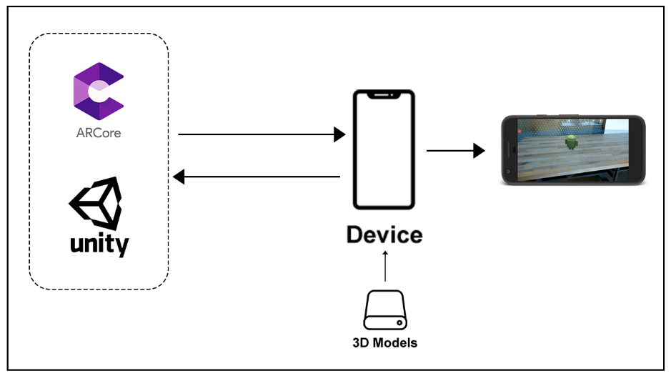This section aims to provide users with a quick comprehension of how the system functions, aiding them in understanding the system better.

*Figure 1. Augmented Reality Workflow Diagram*

The figure above shows the basic workflow/process of the AR App. The process of projecting a 3D model into the augmented world through Augmented Reality involves the device communicating with both the Unity3D Engine and ARCore SDK. To achieve this, ARCore utilizes the SLAM algorithm to determine the device's current proportion, location, and orientation in the real world. Initially, the 3D model is stored within the application itself, and then it proceeds to the Unity3D engine, where the texture and shape of the model are applied. ARFoundation/ARCore then gathers the device's position and orientation information to determine the 3D model's position in the real world. Finally, ARFoundation/ARCore places the 3D model in the augmented world while continuously collecting device position and orientation data.

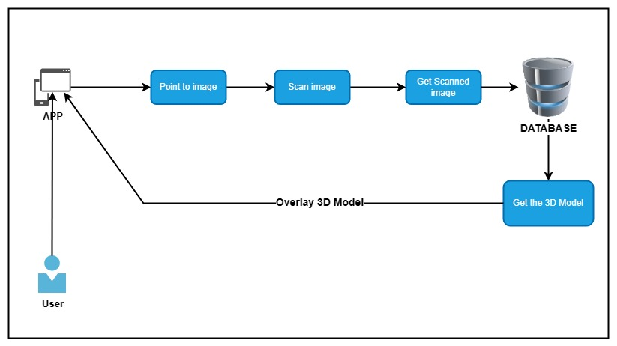The Conceptual framework shows the connection between the system and users, where users can interact with the system by accessing it and using the AR feature by pointing the camera to an image. Additionally, users can create notes within the app, which can be overlaid on the AR. These notes will then be stored in the app's database.

*Figure 2. Sci-AR – Getting 3D Model from database*

In Figure 2. The diagram shows how the system works every time the user tries to scan an image to display a 3D model. First, the user points the phone’s camera into an image and then the system will try to identify the image as it scans and check if the image does exist in its database. After the system identifies the image, the system will retrieve the specific 3D model that is bound for that image and display it the 3D space 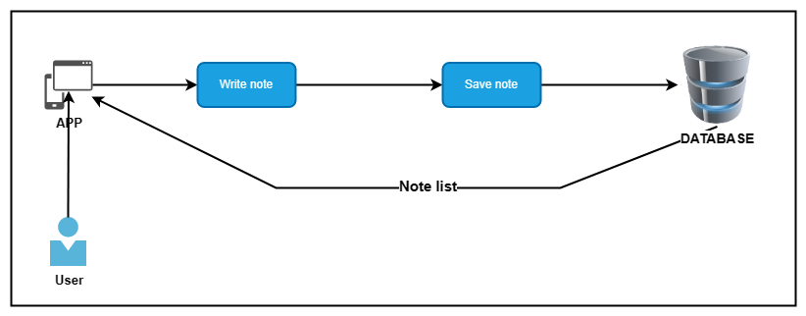of Augmented Reality.

*Figure 3. Sci-AR – Creating/Writing*

Figure 3. shows the workflow diagram of note system where whenever the user creates a note and then saving the note. The created note will be saved in a database and then later will be retrieve to be displayed the list in note menu.

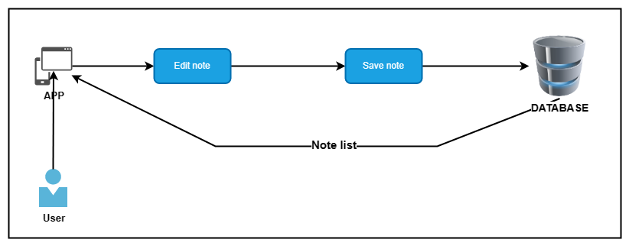

*Figure 4. Sci-AR – Editing existing notes*

In the Figure 4., the diagram shows the system flow when the user edits a note. The user will pick an existing note from the note list and then the picked note will be retrieved from the database. After the finished editing, the note that was saved on the database will be updated.

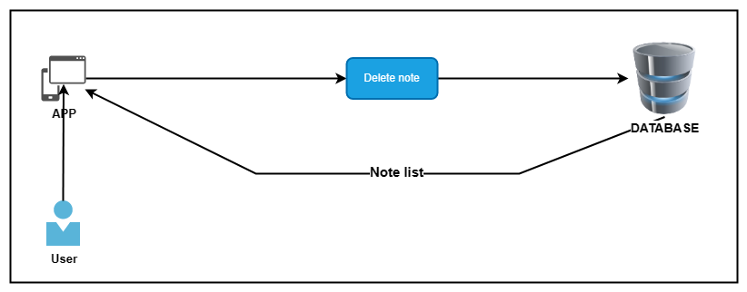

*Figure 5. Sci-AR – Deleting existing notes*

In this Figure 5., it shows whenever the user deletes a note. The user picked a note from the note list and the system will delete the picked note from the database

These are the actions that a user can perform:

1. Use Augmented Reality – the ability of using augmented reality
2. Create Notes – the ability to create notes
3. Edit Notes – the ability to edit existing saved notes
4. Delete Notes – the ability to delete existing saved notes

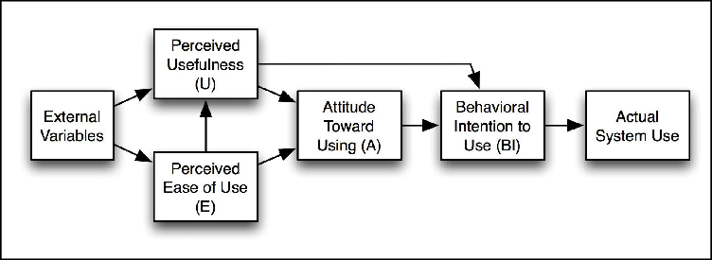**The Theory Used in the Study**

*Figure 6. Technology Acceptance Model*

The Technology Acceptance Model (TAM), which was first presented by Fred Davis in 1986, was described by López et al. (2019). The model indicates that the acceptance of technology for the learning process is influenced by the beliefs and behaviors of its users, as well as the perceived value and ease of usage. Furthermore, TAM is the most widely adopted model and has been used to explain technology acceptance in numerous studies. Additionally, TAM has gained widespread acclaim for its ability to predict students' acceptance of technology and explain their perceptions of embracing technology.

Moreover, by using TAM, the researcher can explore the factors that influence students' attitudes and intentions towards using the Augmented Reality application, such as perceived usefulness, ease of use, and social influence. Additionally, the Technology Acceptance Model (TAM) offers a theoretical framework to identify the factors that impact the adoption of technology, such as Augmented Reality (AR), and how it can affect the learning outcomes of children (Purwaamijaya, 2019).

This will help to ensure that the application meets the needs of the users and is effective in enhancing science learning among Grade 5 students at Tubod Elementary School in Iligan City.

The TAM theory consists of four main factors: perceived ease of use (PEU), perceived usefulness (PU), attitudes toward technology use (ATU), and behavioral intention (BI). In addition, the variability of these four main components can be influenced by factors such as gender, age, experience, and voluntariness of the study participants. Furthermore, the model postulates that the acceptance of a new technology or system is predicated on the levels of Perceived Ease of Use (PEU) and Perceived Usefulness (PU), which in turn influence Behavioral Intention (BI) after being mediated by Attitude Toward Usage (ATU) (Davis, 1989).

*Perceived Usefulness (PU): refers to an individual's perception or belief about how using a specific technology can enhance their performance (Davis, 1989).*

*Perceived Ease of Use (PEU): refers to the extent to which an individual believes that utilizing a specific technology will be effortless (Davis, 1989).*

*Behavioral Intention (BI): BI is a measure that reflects the level of willingness of an individual to exert the necessary effort to perform a desired behavior, such as using computers.*

**Operational Definition of Variables and Terms**

The operational definitions of the following terms were provided to facilitate better comprehension of the study:

**Augmented** world refers to a virtual environment created through augmented  
 reality(AR) technology.

**AR (Augmented Reality)** is a technology that overlays digital information onto  
 the augmented world.

**3D models** are digital representations of three-dimensional objects or  
 environments that can be used in various applications such as games,  
 simulations, and visualizations.

**ARFoundation** is a cross-platform development framework created by Unity

Technologies for augmented reality applications. It enables developers to  
 incorporate AR features such as image tracking and plane detection into their   
 projects while supporting various platforms like iOS, Android, and Windows.

**ARCore** is a software development kit (SDK) developed by Google that  
 enables the creation of augmented reality (AR) applications for mobile devices.

**Android** is a mobile operating system developed by Google.

**Devices** refer to electronic tools or machines designed to perform specific  
 tasks or functions. Android Device will be used for AR.

**Device position and orientation**: refers to the spatial location and orientation   
 of a device. It will be used for AR to project the model.

**Game engines** are software platforms designed to help developers create   
 video games.

**SLAM** (Simultaneous Localization and Mapping) is a technology used in   
 robotics and computer vision for mapping and navigating an environment.

**SDK** stands for software development kit and is a collection of software   
 development tools that allow developers to create applications for specific  
 platforms.

**SQLite** is a relational database management system that is designed to be  
 embedded into software applications.

**Students**, as the system users.

**TAM (Technology Acceptance Model)** - model for understanding how users  
 perceive and adopt new technology.

**Unity3D** is a game engine used for developing 2D and 3D video games.

**CHAPTER 2**

# **REVIEW OF RELATED LITERATURE**

This chapter presents an in-depth analysis of the problem addressed in this study, along with its proposed solution.

**Augmented Reality**

Over the past few decades, the integration of technology in education has brought about a significant change in the way knowledge is imparted to students. With the use of technology combined with effective teaching methodologies, there has been a surge in the development of innovative techniques that aim to enhance the quality of the teaching and learning experience and one such example of technology is Augmented Reality (AR)

Augmented Reality (AR) is a technology that overlays digital content onto the physical world, creating an immersive and interactive user experience. Furthermore, the word "augmented" in "augmented reality" means to enhance or improve something by adding elements to it. In the context of technology, it refers to the enhancement of the physical world through digital elements, such as graphics, sounds, and other sensory inputs, which are overlayed onto real-world objects or environments in real time. This creates an immersive experience that blends the digital and physical worlds together. Moreover, Augmented reality employs two distinct tracking methods: marker-based tracking and markerless tracking. Marker-based tracking utilizes markers with a black and white pattern, featuring a bold black border on a white background. In contrast, markerless tracking can work with markers of any shape. Marker-based tracking is particularly well-suited for paper-based media, as it allows for the display of interactive 3D objects directly above the marker's position on the paper. Users can interact with the augmented content by moving or sliding the paper with the marker (Andrea et al., 2019).

Furthermore, according to Cabero-Almenara and Gimeno. (2019), Augmented Reality (AR) is a developing technology that is becoming more prominent in the field of education. When combined with mobile technology, AR is considered to be one of the most effective tools for facilitating meaningful and widespread learning. Additionally, Augmented Reality (AR) has the potential to revolutionize the way educational materials are presented across all levels of learning, from public outreach events to advanced teaching at the undergraduate and postgraduate levels. The appeal of AR as a teaching aid lies in its capacity to provide a blended learning experience that combines the virtual and real-world environments or materials in the classroom (Barrow et al., 2019) and has the potential to enhance student learning motivation and lead to improved academic achievement (Khan et al., 2019). Besides, it offers a superior user experience as a result of its ability to showcase 3D virtual information and facilitate interaction (Majeed and Ali, 2020).

Similarly, Sahin and Yilmaz (2020) also noted that Augmented Reality (AR) is significant in presenting abstract ideas in a tangible form that matches students' comprehension level, and it allows for the observation of events and objects that would be impossible to experience in real life.

**Technology Acceptance Model (TAM) Theory**

The Technology Acceptance Model (TAM), a theory of information systems, simulates how consumers adopt and use technology. The point at which humans employ technology is during real system use. People utilize technology for a variety of reasons, one of which is behavioral purpose. TAM and its expansions have found usage in a variety of applications across many fields, settings, and places, providing a crucial theoretical tool for forecasting user behavior.

With perceived ease of use and perceived utility as the two main criteria affecting a person's desire to utilize new technology, TAM has been one of the most prominent models of technology acceptance. It has been used in many different sectors, including business, healthcare, and education.

The Technology adoption methodology (TAM) assessment methodology, which was first presented by Fred Davis in 1986, is described by López et al. (2019) and shows that adoption of a technology for the learning process is impacted by beliefs. The behaviors of its users, as well as the perceived value and simplicity of usage.

According to Jang et al. (2021), Several models have been proposed to explain technology acceptance, including the Theory of Reasoned Action (TRA), Technology Acceptance Model (TAM), and Unified Theory of Acceptance and Use of Technology (UTAUT). Among these models, TAM is the most widely adopted and has been used to explain technology acceptance in numerous studies. The TAM has gained widespread acclaim for its ability to anticipate teachers’ adoption of technology and to explain their perceptions of teachers’ embrace of technology.

**Simultaneous Localization and Mapping (SLAM) Algorithm**

SLAM, or simultaneous localization and mapping, is a method used in computer vision and robotics to create or update a map of an uncharted area while simultaneously keeping track of an agent's location inside it. We may employ SLAM techniques in the augmented reality experience to add virtual objects based on the user's observation point (location) and environment structure. Similarly, Singandhupe and La (2020) explained that Simultaneous Localization and Mapping (SLAM) is an algorithm that enables a robot or sensor system to perceive its environment using sensors and estimate its own position in the environment at the same time.

As an example, Liu et al. (2019) cited that for registering both actual and virtual environments in AR, tracking registration technology is essential. The tracking registration method must be able to reliably and swiftly follow a moving subject robustly and in real time, which is more difficult given the irregular camera motions in mobile AR. Additionally, Tang and Cao (2020) also noted that AR technology requires attention to three primary aspects: three-dimensional registration, authenticity in virtual-reality fusion, and effective human-computer interaction. Of these aspects, three-dimensional registration is particularly crucial as it plays a central role in achieving convincing virtual fusion effects. Therefore, one of the primary techniques for 3D registration is Simultaneous Localization and Mapping (SLAM), which is capable of determining the device's position in real-time even in unfamiliar environments (Li et al., 2019).

In addition, ARCore, an augmented reality (AR) platform developed by Google that enables developers to create AR experiences for Android devices. It uses the device's camera, sensors, and motion processors to understand the environment and place virtual objects on top of the real world. Overall, ARCore's use of SLAM technology allows it to create accurate and stable AR experience.

To sum up, Augmented Reality (AR) has emerged as an innovative technology that provides students and teachers with a unique learning experience in science education. The benefits of AR for education are numerous, including enhanced engagement, improved comprehension, and increased motivation.

**CHAPTER 3**

**METHODOLOGY**

The methods and procedures employed by the researcher were utilized to facilitate the development and construction of the suggested system.

**Research Design**

The researcher utilized the Agile Methodology Model for the development of the system. The Agile methodology is a framework for software development that emphasizes collaboration, an iterative approach, and adaptability throughout the software development process (Rachmawati et al., 2021).

Moreover, according to Kaliparambil (2022), the mobile app development process using Agile methodology is highly adaptable, enabling the researcher to customize the timeline based on specific requirements and preferences. This approach prioritizes incremental improvements and offers flexibility in organizing software and mobile app development efforts.

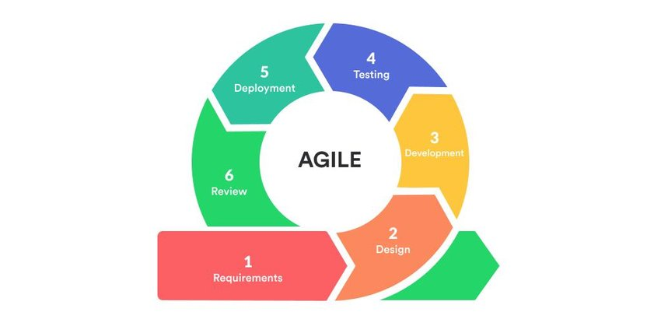

*Figure 7. Agile Methodology*

The aim of this study is to utilize the Agile methodology to create a Mobile Augmented Reality for Science Learning, which will serve as a learning and assessment tool for Tubod Elementary School Grade 5 Students and the general public. This will be achieved through the implementation of the six phases of the Agile methodology.

1. ***Requirements Phase -*** In this phase, the scope of the project determines, prioritize important tasks, and establish key requirements with the client. The requirements will be kept minimal and can be added to later on.
2. ***Design Phase -*** In this phase, an analysis will be performed to determine the appropriate business logic, database models, and technical requirements (languages, data layers, services, etc.) needed to meet the requirements from the previous phase.
3. ***Development and Coding Phase -*** With the planning and analysis out of the way, the actual implementation and coding process can begin. All planning, specification, and design docs up to this point will be coded and implemented into this initial iteration of the project.
4. ***Integration and Testing Phase -*** Once the current build iteration has been coded and implemented, the next step is to go through a series of testing procedures to identify and locate any potential bugs or issues that have cropped up.

These were the procedures observed:

1. Testing the proposed Mobile Augmented Reality Application against the major system.

The previous section mentioned certain functionalities or processes, namely:

System Testing - This test encompasses all the processing scenarios that were evaluated by the system against the expected performance of different users.

Unit Testing - The researcher conducted unit testing to identify and eliminate errors that could cause the program to terminate unexpectedly

1. ***Implementation and Deployment Phase -*** After successful testing, the system is ready to be implemented and deployed.
2. ***Review Phase -*** Once the system is deployed, it will undergo review to determine any improvements or adjustments that need to be made for the next iteration.

**Physical Environment and Resources**

In addressing the physical environment and resource requirements, it's crucial to highlight the hardware prerequisites necessary to design and execute the suggested system effectively.

**Hardware Requirements**

The following computer hardware requirements are necessary to design and execute the suggested system.

*Mobile Device:*

* Android 8.1 Oreo is the most palatable mainstream Android version yet. It is visually consistent, simplified, feature-rich and polished.
* Qualcomm Snapdragon 636 refers to an Octa-Core Processor that comprises eight Kryo 260 cores, which can operate at a maximum clock frequency of 1.8 GHz. The Kryo 260 Cores outperform the ARM Cortex-A53 Cores of SD 630 by 40% in terms of performance. Moreover, MediaTek Helio G35 is a chip that employs an octa-core processor built on 12nm architecture. However, it does not feature the faster A55 or A7x cores, but only Cortex-A53 cores. The processor runs at a speed of 2.3GHz and can support up to 6GB of RAM, which is of the LPDDR4x type with a frequency of 1,600MHz. The chip can also accommodate cheaper LPDDR3 memory with a maximum capacity of 4GB.
* A minimum of 4GB RAM is required for web browsing, social media, video streaming, and some popular mobile games, although the amount of RAM required varies depending on the apps you use (Phillips, 2022). Furthermore, gigabyte (GB) is a measure of digital information equivalent to one billion bytes. It refers to the size of a computer file or software that contains a billion bytes.
* With 64GB, you'll have enough if you use your phone for WhatsApp and calls. In addition, you have space for some social media apps and light games.
* The graphics card should be Adreno 509 for Snapdragon Chipsets and GE8320 for MediaTek Chipset or later that can support Augmented Reality (AR). A chipset refers to a collection of integrated circuits or motherboard chips that are interdependent and responsible for regulating the movement of data and instructions between the CPU or microprocessor and external devices. A graphics card, also known as a display adapter or video card, is a component found in most computing devices that is responsible for rendering graphical data with high clarity, definition, color, and overall visual quality.
* The Camera must at least clear and not blurry in order for ARCore to work correctly.

Provided that the mobile device satisfies the following requirements - Android 8.1 or a later version, sufficient storage space, a high-resolution camera, and support for Augmented Reality, the application can display Augmentation and projections of models without any issues. However, the performance of the system or application depends on how well it is developed.

**Software Requirements**

In terms of software, these are the things that are recommender according to online searches gathered by the researcher.

* C# (pronounced “See Sharp”) is a modern, object-oriented, and type-safe programming language created by Microsoft. C# enables developers to build many types of applications such as Windows client applications, Web services, database applications, and more.
* Unity3D is a cross-platform game engine used for developing 2D and 3D games, simulations, and interactive experiences. It will be used to develop the mobile augmented reality application.
* ARCore is a software development kit (SDK) developed by Google that enables the creation of augmented reality (AR) experiences on Android devices. It will be use to project 3D Objects on real world. ARCore uses Simultaneous Localization and Mapping (SLAM) Algorithm to map the environment and place digital objects in the real world.
* SQLite is a software library that provides a relational database management system. It is designed to be a self-contained, serverless, transactional SQL database engine. SQLite is one of the most widely deployed databases in the world, as it is integrated into many operating systems, browsers, mobile devices, and other software products.

**Tools and Techniques used in the study**

The methods and instruments employed to complete the study consist of utilizing Use Case to demonstrate the capabilities available to the user, and utilizing Activity Diagram to illustrate the interaction between the user and the system.

**Use Case Diagram**

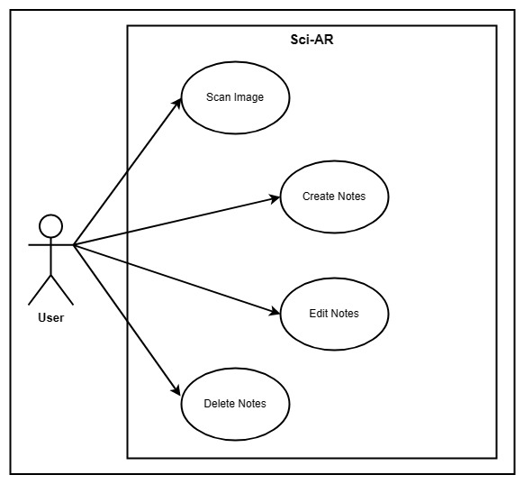

*Figure 8. Use Case Diagram*

A use case diagram is a form of visual modeling that depicts the main components and how they interact in a system. They can be used to identify the major parts of a system and how they interact, which is helpful in ensuring that all necessary steps are taken in order to complete a task. They are also helpful for discovering potential areas for improvement (Mahr, 2023).

**Use Case Diagram Description Table**

|  |  |
| --- | --- |
| **Use Case** | **Description** |
| Scan Image | When user scan an image |
| Create notes | User create notes |
| Edit notes | User edit existing notes |
| Delete notes | User delete existing notes |

*Table 1. Use Case Diagram Description Table*

As shown in the Figure 5, a use case outlines the manner in which an individual utilizing the process or system will achieve an objective.

The user can use the augmented reality with the adherent science book. Additionally, the user can also take a note to save some information and can also later be edit or deleted.

**Sequence Diagram**

Sequence diagram is used to depict the interactions between objects in a system in a sequential order. They are primarily used by developers and business analysts to comprehend project requirements. These diagrams demonstrate the interactions between various parts of the system and the order in which they occur. They display the elements as they interact over time, where the objects are placed on the horizontal axis and time on the vertical axis. The horizontal axis represents the objects interacting with each other, while the vertical axis represents the progress of time (Ijaz, n.d).

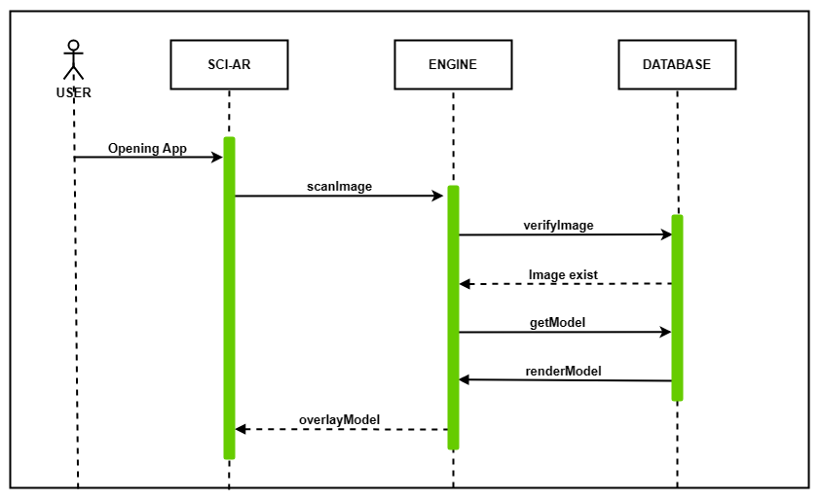*Figure 9. Sequence Diagram*

Figure 9. illustrates the application’s sequence diagram. The user will open the app and instantly be brought to a camera-like UI. Afterwards, the user can use the app to point at the images in the book, and the app will scan the image with the scanImage function and check its existence in the database using the verifyImage function. After verifying its existence, the app will retrieve the corresponding 3D model using getModel function and overlay it into the real world.

**Activity Diagram**

Activity diagram is a modeling tool that is utilized to represent the sequential workflow of a significant activity. It concentrates on the sequences of actions and their corresponding conditions for initiation. The state of an activity is linked to the execution of each step of the workflow.

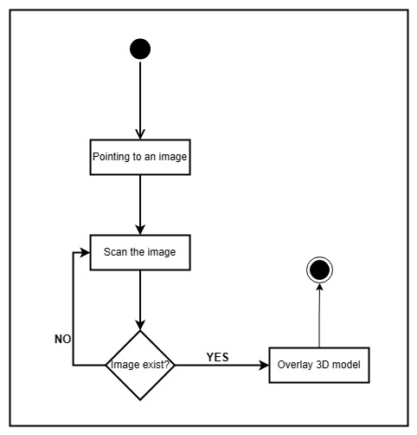

*Figure 10. Activity Diagram*

Figure 10. illustrates a simplified diagram of how the system functions. Initially, the user will be directed to a camera-like UI, which they can utilize to point to an image in the book. The application will then automatically scan the image and check it against the saved images for AR in the database, which also has a corresponding 3D model. Once the model is confirmed, the app will retrieve the corresponding 3D model and overlay it onto the real world.

|  |  |  |  |  |
| --- | --- | --- | --- | --- |
| Field Name | Data Type | Data Format | Field Size | Description |
| note_id | INTEGER |  | 255 | Created note ID |
| Title | VARCHAR |  | 255 | Note title |
| date_created | VARCHAR | MM/DD/YY | 255 | Date note created |
| last_modified | VARCHAR | MM/DD/YY | 255 | Date note last modified |
| note_content | VARCHAR |  | 255 | Note content |

*Table 2. Sci-AR Entity Relationship Diagram*

**Research Setting**

The study will take place at Tubod Elementary School in Iligan City, serving as the primary research site for collecting and analyzing study data.

**Respondents/Informants/Sample and Sampling Method**

The data for the research was gathered from students in the fifth grade, who served as the main data source since they possessed the necessary information for our study. The main source of data for the research will be fifth-grade students at Tubod Elementary School in Iligan City. The primary goal is to gather information from at least 50 participants, as mandated by the study's parameters.

**Data Gathering Method: Instruments and Process**

The survey utilizes questionnaires to present the survey questions. The researchers aim to collect 40 responses from fifth-grade students at Tubod Elementary School in Iligan City, focusing on the use of Augmented Reality in science learning.

The survey questions were strategically designed to gather information about the challenges and performance of Grade 5 students at Tubod Elementary School regarding their science knowledge and learning difficulties. The questionnaire is divided into three segments, aligning with the TAM theory, each carefully crafted to delve into specific aspects relevant to this research.

Additionally, in this section, the researcher provides a description of the table presented below, illustrating the scoring system and corresponding descriptions for each score.

|  |  |  |  |  |
| --- | --- | --- | --- | --- |
| **1**  Strongly Disagree | **2**  Disagree | **3**  Neutral | **4**  Agree | **5**  Strongly Agree |

*Table 3. Likert Scale Used in the Questionnaire*

The table elucidates the standardized scoring for questions within the TAM questionnaire. To clarify, "Strongly Disagree" denotes the lowest score, while "Strongly Agree" signifies the highest score in the scoring continuum.

**Data Analysis Method**

In this study, the researcher employed descriptive analysis to examine the data in the research project titled "Sci-AR: Enhance Science Learning Through Augmented Reality." By utilizing descriptive statistics, we gained insights into the types of science content that should be included in our Augmented Reality application.

To summarize the distribution of the variables, the researcher calculated various measures of central tendency and variability, such as the mean, median, mode, and standard deviation. These calculations allowed us to better understand the characteristics of our sample of respondents and identify any potential anomalies in the data.

In conclusion, descriptive statistics played a crucial role as the primary method of statistical analysis, enabling us to gain a deeper understanding of the characteristics of our respondents. Through this technique, we identified trends and presented the data in a meaningful way, providing valuable guidance for decision-making regarding our Augmented Reality application.

**Research Ethics**

The researcher prioritized ethical considerations throughout the data collection process in conducting this study. The following measures were implemented to uphold research ethics:

**Informed Consent**: Prior to conducting the interviews, the researcher obtained consent from the BED principal. The approval was sought through a formal letter signed by the dean and our advisor, clearly outlining the purpose, nature, and intended use of the provided information.

**Respect for Participants**: The survey was conducted in a respectful and professional manner, adhering to moral principles. The researcher ensured that survey participants felt valued and respected throughout the process.

**Confidentiality**: Any personally identifiable or sensitive data shared during the survey was treated with the utmost care to protect the privacy and confidentiality of the respondents. Only the research team had access to securely stored survey questionnaires.

**Voluntary Participation**: Respondents willingly participated in the survey, with the understanding that they could withdraw their consent at any time without facing any consequences.

**Data Accuracy and Validity**: The researcher provided survey participants with a questionnaire and offered clear instructions to minimize missing data and ensure data accuracy.

**Institutional Approval**: To further uphold ethical standards, the study project obtained necessary permissions from relevant institutional entities, including the dean's office and our advisor.

**Use of Information**: The information gathered from the survey was solely used for the specific research project on Sci-AR: Enhance Science Learning Through Augmented Reality. All provided information was treated with integrity and solely utilized for research purposes related to the project.

By adhering to these ethical guidelines, we safeguarded the safety and well-being of the participants, as well as the validity and integrity of the study process.

**CHAPTER 4**

**PRESENTATION, ANALYSIS AND INTERPRETATION OF DATA**

This portion presents the outcomes of the evaluation and analysis of the system. It encompasses the visual representation, examination, and elucidation of data obtained through the distribution of questionnaires to the participants. Additionally, it encompasses the tabular display of data accompanied by their corresponding explanations.

**Objective 1: Develop A Learning App for Learning Science which include the following functionalities.**

* 1. **Note taking feature**
     1. *Creating notes*

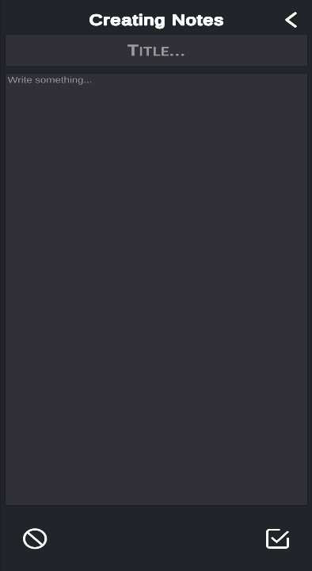

*Figure 11. Note creation*

**

*Figure 12. Note creation code*

The Figure 11 shows the panel for creating notes where inside the panel there is two inputs which the top is for title of the note and the bottom is for the content of the note. Meanwhile, the Figure 12 shows the entire code for the note creation.

* + 1. ***List*** *of Created Notes*

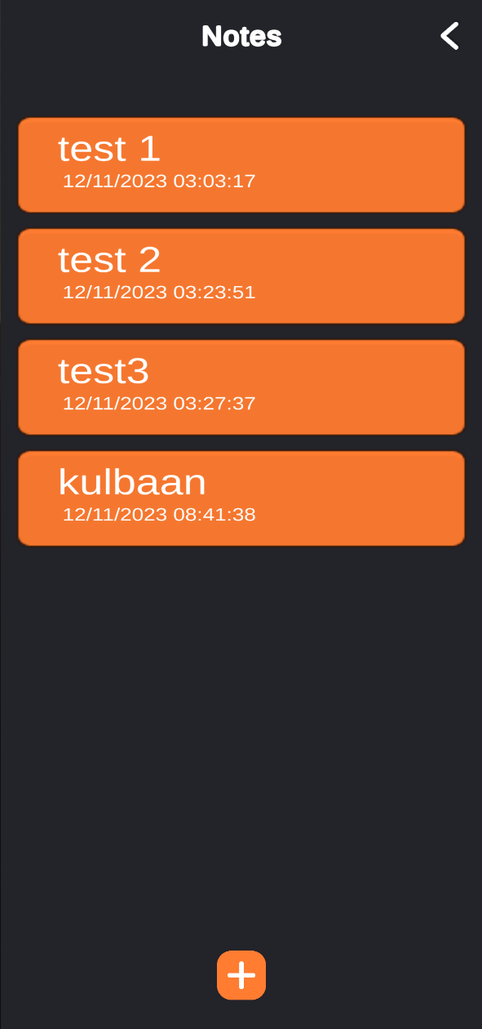

*Figure 13. View list of created notes*

**

**

*Figure 14. View list of created notes code*

Figure 13 shows the panel where it displays all the notes created as a list. Additionally, Figure 14 shows the entire code for showing the created notes on the panel.

* + 1. *Edit Created Notes*

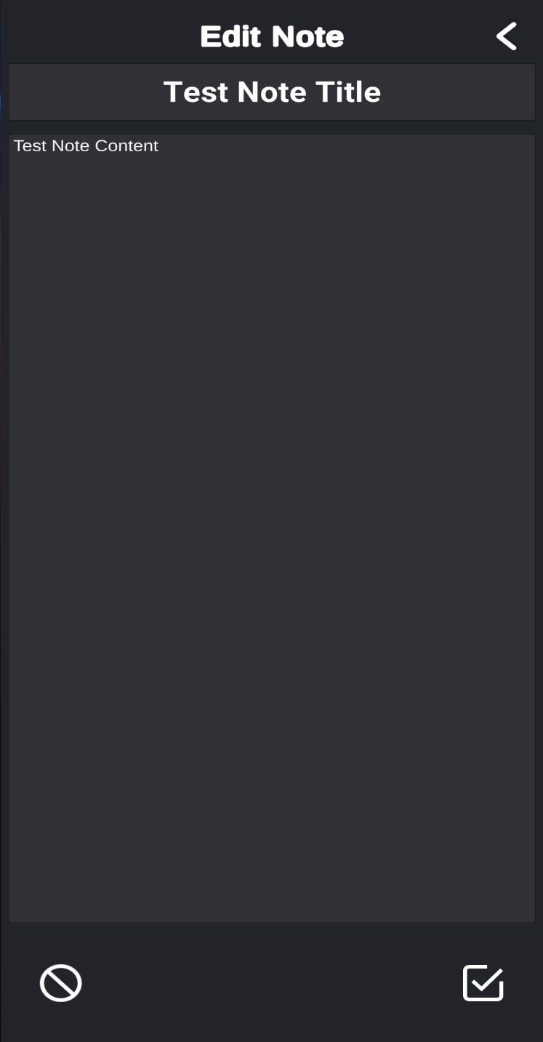

*Figure 15. Edit created notes*

**

*Figure 16. Edit created notes code*

The Figure 15 display another panel for note editing. It shows the title and the content of the note. On the other hand, Figure 16 shows the code for editing/updating the selected note.

* + 1. *View and Delete Created Note*

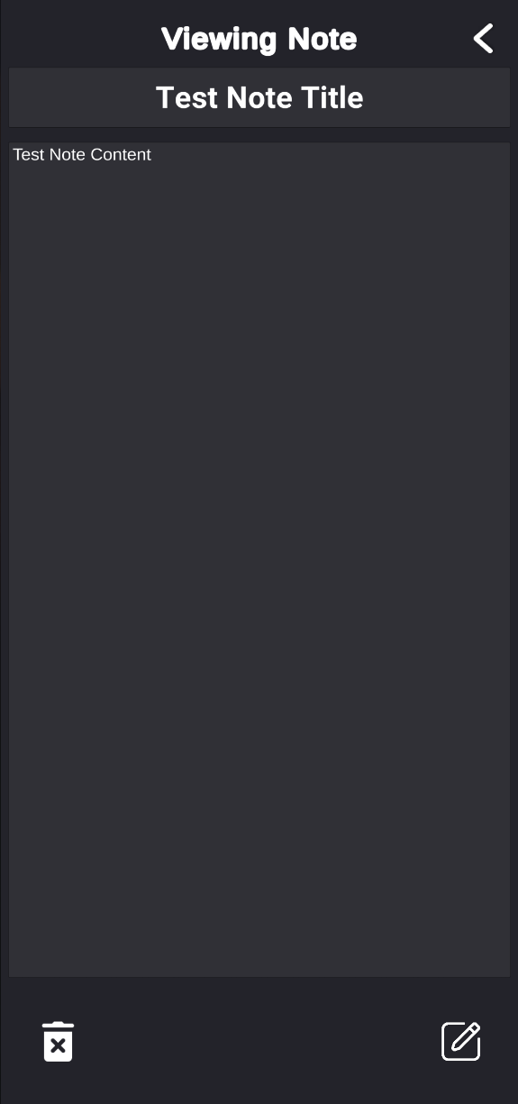

*Figure 17. View and Delete created notes*

**

*Figure 18. View created notes code*

**

*Figure 19. Delete created notes code*

Figure 17 shows the panel for viewing the created note. When a note on the note list, it will show the note as read-only mode. There are also the buttons in the

panel for editing and deleting note. Figure 18 shows the code for viewing the notes and Figure 19 shows how the code of how to delete a note.

* 1. Augmented Reality
     1. *Use Augmented Reality*

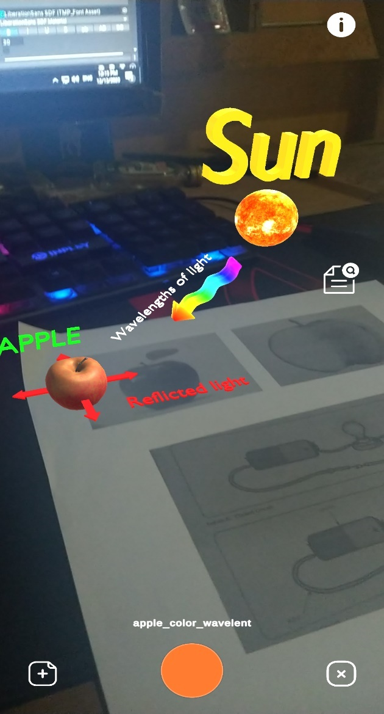

*Figure 20. Projecting 3D Model using Augmented Reality*

**





*Figure 21. Projecting 3D Model using Augmented Reality Code*

Figure 20 shows the Augmented Reality(AR) feature of the app. It scan images and compare that scanned images that it has then project the 3D Object using Augmented Reality. The Images is pre-loaded thus it only scan what image is already loaded by the system. Additionally, Figure 21 shows it’s code on how the Augmented Reality works by

* + 1. *3D Model Notes*

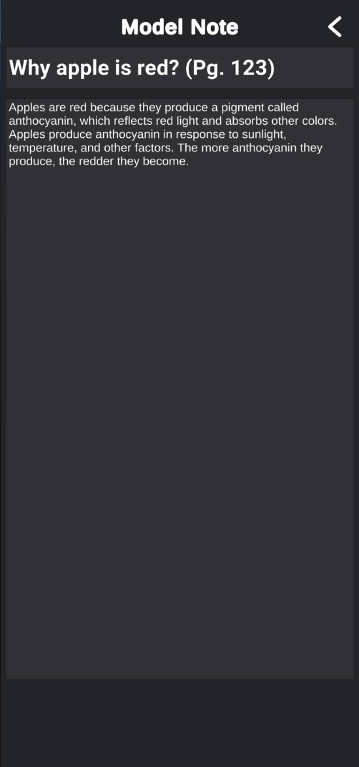

*Figure 22. 3D Model Notes*

**

**

**

**

*Figure 23. 3D Model Notes Code*

Figure 22 is a note feature for every 3D objects. Means that every 3D Object has it’s own static notes to explain what is being shown. The note button only appear on the screen when a 3D Object is being projected then hide when the 3D Object is destroyed. Figure 23 shows the code for static notes of 3D Objects.

* + 1. *3D Model List*

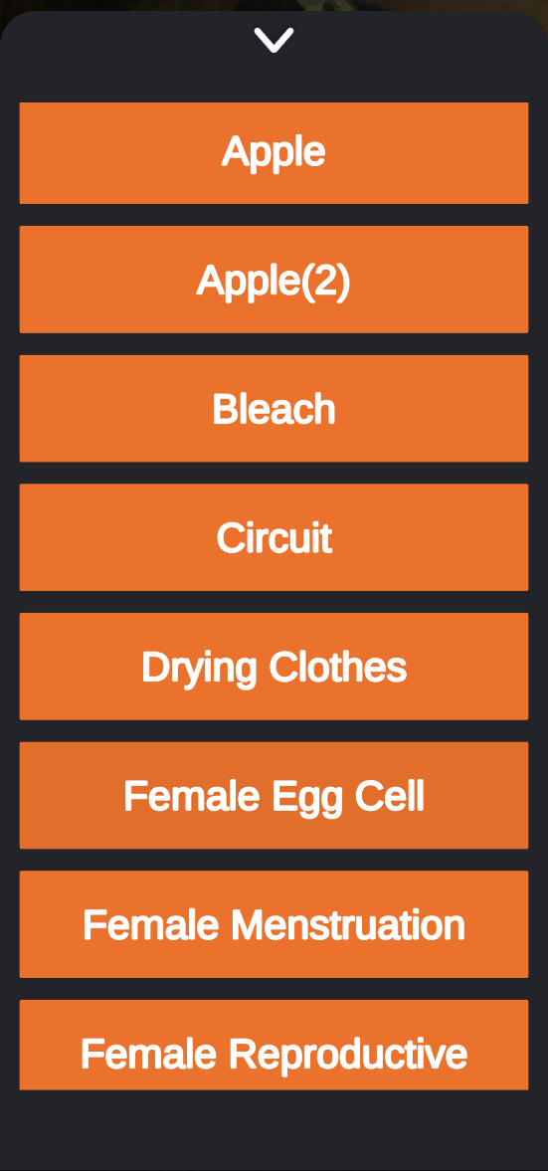

*Figure 24. 3D Model List*

**

*Figure 25.* *3D Model List Code*

Figure 24 is a panel for the list of all the 3D Objects the app has. There are currently 17 3D models available. Figure 25 shows the code of displaying the 3D model on the list panel.

**Objective 2: Evaluate the acceptance level and efficacy of Sci-AR Application**

*Profile of the Tubod, Elementary School Pupils*

**__________________________________________________________________**

FREQUENCY PERCENTAGE

**Gender**Male 23 56.1%

Female 18 43.9%

*Table 4*. Tubod Elementary School Pupils

The table presents data gathered from students for the evaluation of Sci-AR: Enhance Science Learning Through Augmented Reality. Out of the respondents, 43.9% were female, and 56.1% were male. All participants belong to the fifth grade, with an average age of 11, constituting 48.8% of the overall sample. This information provides insight into the demographic composition of those who participated in the assessment.

*Acceptance Level of the Student’s using the Technology Acceptance Model*

**Perceived Ease of Use** Mean Verbal Description

|  |  |  |
| --- | --- | --- |
| I feel that using Sci-AR would be easy for me. | 2.19 | Disagree |
| I feel that using Sci-AR would be clear and understandable | 2.36 | Disagree |
| Learning to operate Sci-AR would be easy to me. | 2.46 | Disagree |
| It would be easy for me to become productive at using Sci-AR. | 2.48 | Disagree |
| I feel that using Sci-AR would improve my overall performance. | 2.07 | Disagree |

**Perceived Usefulness**

|  |  |  |
| --- | --- | --- |
| Using Sci-AR would improve my learning. | 3.92 | Agree |
| Using Sci-AR would enable me to understand science more quickly. | 3.68 | Agree |
| I would find Sci-AR useful in learning and understanding hard-to-get science concepts. | 3.90 | Agree |
| Using Sci-AR would enhance my effectiveness. | 3.75 | Agree |
| Using Sci-AR would make it easier to learn science. | 4.02 | Agree |

**Attitude toward Using**

|  |  |  |
| --- | --- | --- |
| I like doing my tasks using Sci-AR. | 3.95 | Agree |
| I have positive feelings towards using Sci-AR. | 4.02 | Agree |
| I look forward to those aspects of my tasks that requires me to use Sci-AR. | 4.09 | Agree |
| I think that using Sci-AR is a good idea. | 4.09 | Agree |
| I intend to use Sci-AR frequently. | 3.92 | Agree |

Overall Mean 3.4 Agree

**___________________________________________________________________**

*Table 5*. Student’s Acceptance Level

The table illustrates the students' receptiveness to Sci-AR: Enhance Science Learning Through Augmented Reality, employing the Technology Acceptance Model. Mean and Standard Deviation metrics are employed to gauge the acceptance level of Sci-AR. The findings reveal a mean score of 3.4. This suggests a positive inclination among students towards utilizing Sci-AR for enhanced science learning. Consequently, respondents express a high level of confidence in the effectiveness of science learning with Augmented Reality, anticipating benefits such as facilitating easier science comprehension, increasing productivity, and enhancing overall academic performance.

**CHAPTER 5**

**SUMMARY, CONCLUSION, AND RECOMMENDATION**

This chapter provides an overview of the data collected during the study and presents the conclusions drawn from the research. Additionally, it offers recommendations for potential implementation in future research endeavors.

**Summary Of Findings**

The study yielded positive results, as indicated below:

1. Out of the respondents, 43.9% were female, and 56.1% were male.
2. Using the Technology Acceptance Model, indicates positive student receptiveness to Sci-AR for enhanced science learning has mean of 3.4. Respondents’ express confidence in its effectiveness, anticipating benefits such as easier comprehension, increased productivity, and enhanced academic performance.

**Conclusion**The study concludes with the following conclusions in light of its findings.

Following the evaluation, the majority of respondents approved Sci-AR: Enhance Science Learning Through Augmented Reality. It demonstrates that respondents' attitudes on using Sci-AR: Enhance Science Learning Through Augmented Reality are influenced by how simple and practical they believe the technology to be. This suggests that Sci-AR: Enhance Science Learning Through Augmented Reality has a favorable effect since students' attitudes improve for every perceived utility and ease of usage. Thus, it can be concluded that students benefit from Sci-AR: Enhance Science Learning Through Augmented Reality.

**Recommendations**

The system suggests the following based on the results and the experiences of the students:

1. More 3D models to be added.
2. Text-to-Speech note.
3. More animated 3D models.
4. Updated contents of 3D Models.

# **REFERENCES**

Andrea, R., Lailiyah, S., Agus, F., & Ramadiani, R. (2019). “Magic Boosed” an elementary school geometry textbook with marker-based augmented reality. *TELKOMNIKA (Telecommunication Computing Electronics and Control)*, *17*(3), 1242-1249. <http://doi.org/10.12928/telkomnika.v17i3.11559>

Turan Z., & Atila G. (2021). Augmented reality technology in science education for students with specific learning difficulties: its effect on students’ learning and views, Research in Science & Technological Education.

<https://doi.org/10.1080/02635143.2021.1901682>

Tasneem K., Kevin J., Jacques O. (2019). "The Impact of an Augmented Reality Application on Learning Motivation of Students", *Advances in Human-Computer Interaction*, vol. 2019, Article ID 7208494, 14 pages, 2019. <https://doi.org/10.1155/2019/7208494>

Barrow, John & Sands, Andrew & Hurst, William. (2019). Augmented Reality for Enhancing Life Science Education. <https://www.researchgate.net/publication/340897891_Augmented_Reality_for_Enhancing_Life_Science_Education>

Sahin D. & Yilmaz R.M. (2019). The effect of Augmented Reality Technology on middle school students' achievements and attitudes towards science education, Computers & Education (2019), doi: <https://doi.org/10.1016/j.compedu.2019.103710>

Rishka L., Nadiran A. , Anisah P., Alexander G. (2019). A Systematic Literature Review: Learning with Visual by The Help of Augmented Reality Helps Students Learn Better. a Computer Science Department, School of Computer Science, Bina Nusantara University, Jakarta, Indonesia. <https://doi.org/10.1016/j.procs.2020.12.019>

Jessup, S. A., Schneider, T. R., Alarcon, G. M., Ryan, T. J., & Capiola, A. (2019). The Measurement of the Propensity to Trust Technology. <https://www.researchgate.net/profile/Tamera-Schneider-2/publication/334344580_The_Measurement_of_the_Propensity_to_Trust_Automation/links/5e501f76a6fdcc2f8f552ba8/The-Measurement-of-the-Propensity-to-Trust-Automation.pdf>

Davis, F. D. (1989). Perceived usefulness, perceived ease of use, and user acceptance of information technology. DOI: <https://doi.org/10.2307/249008>

López G., Rocio B., Cuji M., Abásolo J., & Aguirre Sailema L. (2019). "Technological Acceptance Model (TAM) using Augmented Reality in University Learning Scenarios," 2019 14th Iberian Conference on Information Systems and Technologies (CISTI), Coimbra, Portugal, 2019, pp. 1-6, doi: <https://doi.org/10.23919/CISTI.2019.8760784>

Purwaamijaya, B. M. (2019). Technology Acceptance Model (TAM) on Augmented Reality Affecting The Education Of Children (Case Study Octagon Studio). *Jurnal Tam Tamo Btari*. <https://osf.io/2j74y/>

Cabero-Almenara, J., & Martínez Gimeno, A. (2019). Las tecnologías de la información y comunicación y la formación inicial de los docentes: modelos y competencias digitales. <https://doi.org/10.30827/profesorado.v23i3.9421>

Khan, T., Johnston, K., & Ophoff, J. (2019). The impact of an augmented reality application on learning motivation of students. *Advances in human-computer interaction*, *2019*. <https://doi.org/10.1155/2019/7208494>

Majeed, Z. H., & Ali, H. A. (2020). A review of augmented reality in educational applications. *International Journal of Advanced Technology and Engineering Exploration*. <https://www.researchgate.net/profile/Zainab-Alfayez-2/publication/344308958_A_review_of_augmented_reality_in_educational_applications/links/5f65c180a6fdcc00862d3261/A-review-of-augmented-reality-in-educational-applications.pdf>

Jang, J., Ko, Y., Shin, W. S., & Han, I. (2021). Augmented reality and virtual reality for learning: An examination using an extended technology acceptance model. <https://ieeexplore.ieee.org/abstract/document/9312165/>

Singandhupe, A., & La, H. M. (2020). Mcc-ekf for autonomous car security. In *2020 Fourth IEEE International Conference on Robotic Computing (IRC)*. [https://ieeexplore.ieee.org/abstract/document/9287976/](https://ieeexplore.ieee.org/abstract/document/9287976/%20)

Liu, L., Li, H., & Gruteser, M. (2019). Edge assisted real-time object detection for mobile augmented reality. In *The 25th annual international conference on mobile computing and networking.* <https://doi.org/10.1145/3300061.3300116>

Tang, B., & Cao, S. (2020). A review of VSLAM technology applied in augmented reality. In *IOP Conference Series: Materials Science and Engineering*. [https://doi.org/10.1088/1757-899X/782/4/042014](%20https:/doi.org/10.1088/1757-899X/782/4/042014)

Li, J., Li, Z., Feng, Y., Liu, Y., & Shi, G. (2019). Development of a human–robot hybrid intelligent system based on brain teleoperation and deep learning SLAM. [*https://doi.org/*10.1109/TASE.2019.2911667](https://doi.org/10.1109/TASE.2019.2911667)

Rachmawati, F., Suryajaya, B., & Hardian, B. (2021). Impact of Changing Scope and Customer Involvement to Perceived Benefit. In *2021 4th International Conference of Computer and Informatics Engineering (IC2IE)*. <https://doi.org/10.1109/IC2IE53219.2021.9649115>

Kaliparambil.S. (2022). Using Agile Methodology Effectively in Mobile App Development. <https://geekyants.com/blog/using-agile-methodology-effectively-in-mobile-app-development/>

Phillips. G. (2022). How Much RAM Does a Smartphone Need? <https://www.makeuseof.com/how-much-ram-smartphone-need/>

Mahr. N. (2023). Use Case Diagram, Document & Template. <https://study.com/learn/lesson/use-case-diagram-template.html>

Ijaz. U.(n.d) What is a sequence diagram? <https://www.educative.io/answers/what-is-a-sequence-diagram>

# **APPENDICES**

#### Appendix A

Letter of Approval

Appendix B

#### Survey Questionnaire

Adopted From: [aha gikan ang study]

**Sci-AR**: Enhance Science Learning Through Augmented Reality

**NAME:** ______________________________________

**GENDER:** Male Female Others

**Instruction**: Check the box below to your corresponding answer.

|  |  |  |  |  |
| --- | --- | --- | --- | --- |
| **5**  Strongly Disagree | **4**  Disagree | **3**  Neutral | **2**  Agree | **1**  Strongly Agree |

|  |  |  |  |  |  |
| --- | --- | --- | --- | --- | --- |
| **Perceived Ease of Use** | **5** | **4** | **3** | **2** | **1** |
| 1. I feel that using Sci-AR would be easy for me. |  |  |  |  |  |
| 2. I feel that using Sci-AR would be clear and understandable |  |  |  |  |  |
| 3. Learning to operate Sci-AR would be easy to me. |  |  |  |  |  |
| 4. It would be easy for me to learn science at using Sci-AR. |  |  |  |  |  |
| 5. I feel that using Sci-AR would improve my understanding about science. |  |  |  |  |  |

|  |  |  |  |  |  |
| --- | --- | --- | --- | --- | --- |
| **Perceived Usefulness** | **5** | **4** | **3** | **2** | **1** |
| 1. Using Sci-AR would improve my learning. |  |  |  |  |  |
| 2. Using Sci-AR would enable me to understand science concepts more quickly. |  |  |  |  |  |
| 3. I would find Sci-AR useful in learning and understanding hard-to-get science concepts. |  |  |  |  |  |
| 4. Using Sci-AR would enhance my effectiveness. |  |  |  |  |  |
| 5. Using Sci-AR would make it easier to learn science. |  |  |  |  |  |

|  |  |  |  |  |  |
| --- | --- | --- | --- | --- | --- |
| **Attitude Towards Using** | **5** | **4** | **3** | **2** | **1** |
| 1. I like doing my task using Sci-AR. |  |  |  |  |  |
| 2. I have positive feelings towards using Sci-AR. |  |  |  |  |  |
| 3. I look forward to those aspects of my tasks that requires me to use Sci-AR. |  |  |  |  |  |
| 4. I think that using Sci-AR is a good idea. |  |  |  |  |  |
| 5. I intend to use Sci-AR frequently. |  |  |  |  |  |

Appendix C

#### Data Sets

This table represents the general point average of the respondents.

Table 6. Point Average of the Respondents

|  |  |  |  |  |  |
| --- | --- | --- | --- | --- | --- |
| **RESPONDENTS** | **Q1** | **Q2** | **Q3** | **Q4** | **Q5** |
| 1 | 2 | 1 | 1 | 1 | 2 |
| 2 | 1 | 1 | 4 | 1 | 3 |
| 3 | 3 | 4 | 4 | 3 | 4 |
| 4 | 4 | 2 | 3 | 3 | 2 |
| 5 | 1 | 1 | 4 | 3 | 1 |
| 6 | 1 | 3 | 1 | 4 | 2 |
| 7 | 1 | 3 | 4 | 3 | 1 |
| 8 | 4 | 1 | 4 | 3 | 3 |
| 9 | 4 | 4 | 2 | 4 | 4 |
| 10 | 1 | 2 | 4 | 3 | 2 |
| 11 | 4 | 4 | 4 | 1 | 1 |
| 12 | 1 | 4 | 1 | 1 | 1 |
| 13 | 1 | 1 | 1 | 1 | 1 |
| 14 | 1 | 2 | 2 | 1 | 3 |
| 15 | 1 | 1 | 4 | 3 | 2 |
| 16 | 4 | 3 | 4 | 4 | 3 |
| 17 | 4 | 2 | 1 | 4 | 2 |
| 18 | 2 | 1 | 2 | 2 | 1 |
| 19 | 1 | 4 | 2 | 4 | 1 |
| 20 | 4 | 3 | 4 | 4 | 1 |
| 21 | 3 | 2 | 2 | 2 | 2 |
| 22 | 3 | 4 | 4 | 3 | 4 |
| 23 | 1 | 1 | 1 | 4 | 1 |
| 24 | 4 | 4 | 4 | 4 | 4 |
| 25 | 1 | 2 | 1 | 3 | 1 |
| 26 | 2 | 3 | 2 | 2 | 3 |
| 27 | 1 | 1 | 4 | 3 | 2 |
| 28 | 1 | 1 | 1 | 1 | 1 |
| 29 | 3 | 3 | 3 | 4 | 2 |
| 30 | 4 | 1 | 1 | 4 | 4 |
| 31 | 1 | 1 | 1 | 1 | 1 |
| 32 | 3 | 4 | 3 | 1 | 1 |
| 33 | 1 | 3 | 2 | 2 | 2 |
| 34 | 3 | 3 | 3 | 3 | 3 |
| 35 | 4 | 4 | 1 | 1 | 1 |
| 36 | 4 | 4 | 1 | 1 | 4 |
| 37 | 2 | 2 | 2 | 3 | 2 |
| 38 | 1 | 1 | 4 | 1 | 1 |
| 39 | 1 | 1 | 1 | 1 | 1 |
| 40 | 1 | 1 | 1 | 4 | 1 |
| 41 | 1 | 4 | 3 | 1 | 4 |
|  |  |  |  |  |  |
| **MEAN** | **2.195121951** | **2.365853659** | **2.463414634** | **2.487804878** | **2.073170732** |

|  |  |  |  |  |  |
| --- | --- | --- | --- | --- | --- |
| **RESPONDENTS** | **Q6** | **Q7** | **Q8** | **Q9** | **Q10** |
| 1 | 5 | 1 | 5 | 1 | 5 |
| 2 | 5 | 5 | 4 | 3 | 5 |
| 3 | 4 | 5 | 3 | 4 | 3 |
| 4 | 1 | 2 | 1 | 1 | 2 |
| 5 | 5 | 4 | 5 | 3 | 5 |
| 6 | 5 | 3 | 4 | 5 | 2 |
| 7 | 3 | 5 | 4 | 3 | 5 |
| 8 | 4 | 3 | 3 | 3 | 3 |
| 9 | 3 | 2 | 1 | 5 | 2 |
| 10 | 5 | 3 | 5 | 4 | 4 |
| 11 | 5 | 4 | 4 | 5 | 5 |
| 12 | 4 | 3 | 2 | 4 | 5 |
| 13 | 5 | 3 | 5 | 4 | 5 |
| 14 | 1 | 3 | 5 | 1 | 3 |
| 15 | 3 | 4 | 5 | 4 | 1 |
| 16 | 5 | 5 | 4 | 4 | 4 |
| 17 | 4 | 4 | 4 | 4 | 5 |
| 18 | 5 | 5 | 5 | 5 | 5 |
| 19 | 1 | 2 | 5 | 4 | 3 |
| 20 | 5 | 4 | 4 | 5 | 5 |
| 21 | 4 | 3 | 4 | 4 | 3 |
| 22 | 3 | 3 | 3 | 3 | 3 |
| 23 | 5 | 5 | 5 | 5 | 5 |
| 24 | 4 | 4 | 4 | 4 | 4 |
| 25 | 5 | 3 | 5 | 5 | 5 |
| 26 | 4 | 3 | 4 | 4 | 3 |
| 27 | 4 | 3 | 5 | 4 | 5 |
| 28 | 3 | 5 | 5 | 2 | 5 |
| 29 | 3 | 4 | 4 | 3 | 4 |
| 30 | 4 | 4 | 3 | 3 | 5 |
| 31 | 4 | 4 | 4 | 5 | 5 |
| 32 | 4 | 5 | 4 | 3 | 4 |
| 33 | 2 | 1 | 3 | 4 | 5 |
| 34 | 4 | 4 | 3 | 4 | 3 |
| 35 | 4 | 5 | 4 | 5 | 4 |
| 36 | 4 | 5 | 4 | 4 | 4 |
| 37 | 5 | 3 | 2 | 3 | 4 |
| 38 | 5 | 4 | 3 | 4 | 5 |
| 39 | 4 | 4 | 4 | 4 | 4 |
| 40 | 5 | 4 | 5 | 4 | 5 |
| 41 | 3 | 5 | 4 | 5 | 3 |
|  |  |  |  |  |  |
| **MEAN** | **3.926829268** | **3.682926829** | **3.902439024** | **3.756097561** | **4.024390244** |

|  |  |  |  |  |  |
| --- | --- | --- | --- | --- | --- |
| **RESPONDENTS** | **Q11** | **Q12** | **Q13** | **Q14** | **Q15** |
| 1 | 5 | 5 | 5 | 5 | 5 |
| 2 | 4 | 2 | 5 | 4 | 5 |
| 3 | 3 | 3 | 4 | 3 | 4 |
| 4 | 1 | 1 | 1 | 1 | 1 |
| 5 | 5 | 3 | 5 | 4 | 5 |
| 6 | 2 | 3 | 5 | 4 | 2 |
| 7 | 4 | 5 | 5 | 3 | 4 |
| 8 | 3 | 3 | 5 | 5 | 5 |
| 9 | 5 | 3 | 1 | 5 | 3 |
| 10 | 5 | 5 | 2 | 5 | 1 |
| 11 | 4 | 4 | 5 | 4 | 5 |
| 12 | 3 | 3 | 4 | 4 | 3 |
| 13 | 5 | 4 | 5 | 5 | 3 |
| 14 | 3 | 5 | 1 | 3 | 4 |
| 15 | 4 | 4 | 5 | 4 | 5 |
| 16 | 5 | 5 | 5 | 5 | 5 |
| 17 | 5 | 5 | 5 | 4 | 4 |
| 18 | 5 | 5 | 5 | 5 | 5 |
| 19 | 5 | 4 | 5 | 2 | 3 |
| 20 | 5 | 4 | 5 | 5 | 5 |
| 21 | 3 | 4 | 3 | 3 | 4 |
| 22 | 4 | 4 | 3 | 4 | 3 |
| 23 | 5 | 4 | 5 | 5 | 5 |
| 24 | 5 | 5 | 5 | 4 | 4 |
| 25 | 5 | 4 | 5 | 2 | 5 |
| 26 | 3 | 4 | 4 | 4 | 3 |
| 27 | 3 | 4 | 4 | 5 | 5 |
| 28 | 5 | 5 | 5 | 4 | 5 |
| 29 | 4 | 4 | 3 | 5 | 3 |
| 30 | 3 | 4 | 4 | 5 | 3 |
| 31 | 4 | 4 | 5 | 5 | 4 |
| 32 | 3 | 4 | 4 | 5 | 4 |
| 33 | 2 | 3 | 4 | 2 | 3 |
| 34 | 3 | 4 | 4 | 4 | 3 |
| 35 | 4 | 5 | 4 | 5 | 5 |
| 36 | 5 | 5 | 5 | 5 | 5 |
| 37 | 5 | 3 | 4 | 4 | 2 |
| 38 | 4 | 4 | 3 | 4 | 4 |
| 39 | 4 | 5 | 5 | 5 | 4 |
| 40 | 4 | 5 | 3 | 4 | 5 |
| 41 | 4 | 5 | 3 | 4 | 5 |
|  |  |  |  |  |  |
| **MEAN** | **3.975609756** | **4.024390244** | **4.097560976** | **4.097560976** | **3.926829268** |

|  |  |
| --- | --- |
| **MEAN** |  |
| Q1 | *2.195122* |
| Q2 | *2.365854* |
| Q3 | *2.463415* |
| Q4 | *2.487805* |
| Q5 | *2.073171* |
|  |  |
| Q6 | *3.926829* |
| Q7 | *3.682927* |
| Q8 | *3.902439* |
| Q9 | *3.756098* |
| Q10 | *4.02439* |
|  |  |
| Q11 | *3.97561* |
| Q12 | *4.02439* |
| Q13 | *4.097561* |
| Q14 | *4.097561* |
| Q15 | *3.926829* |
|  |  |
| **OVERALL MEAN** | ***3.4*** |

Appendix D

#### Photo Documentation

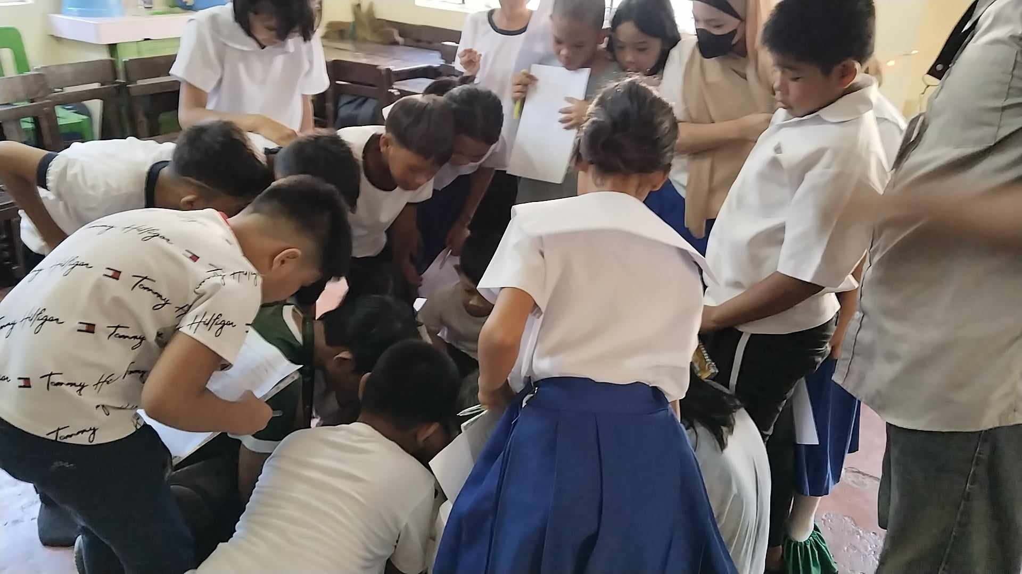

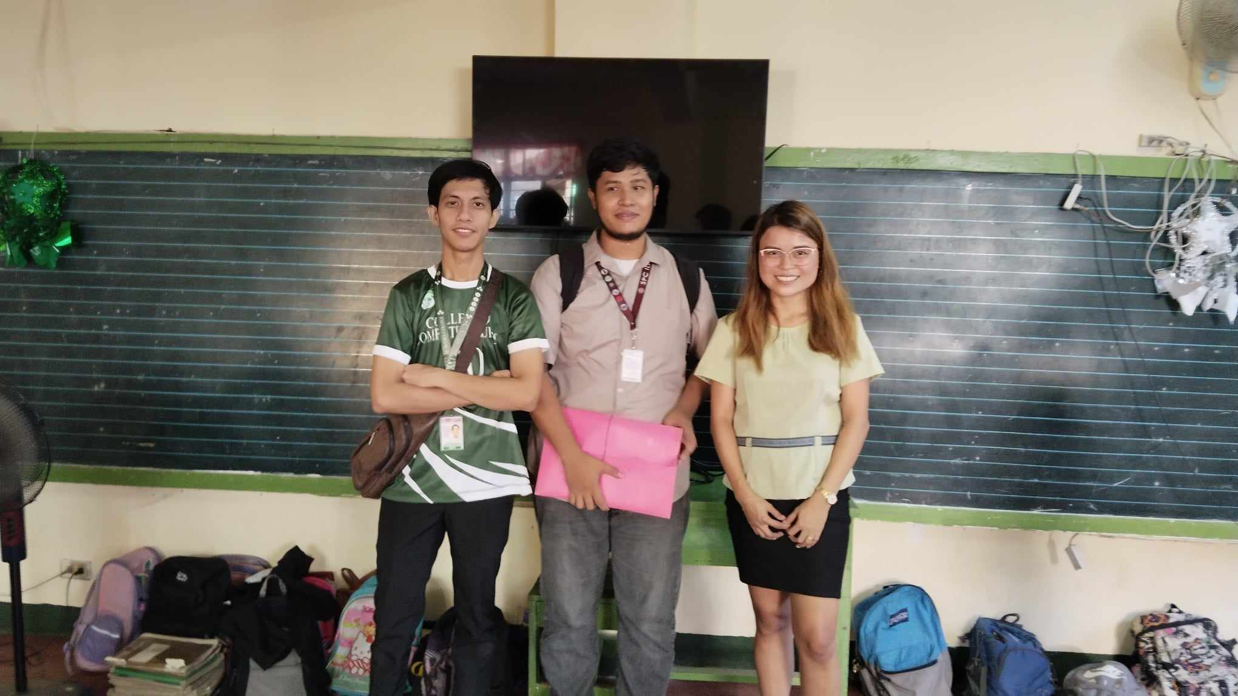**Figure 26.** Respondents trying out Sci-AR

**Figure 27.** The researcher (Left) with the student’s teacher (Right)

**VITA**

**PERSONAL INFORMATION**

 **Name**: Edward Jr A. Cabello

**Address**: Purok 5 Saray, Iligan City

**Email**: [eddshine5@gmail.com](mailto:eddshine5@gmail.com)

**Mobile**: 09551071807

**Age**: 23 Years Old

**Gender**: Male

**Height**: 179cm

**Weight**: 52kg

**Father’s** **Name**: Eduardo M. Cabello Sr.

**Mother’s** **name**: Nida A. Cabello

**Educational** **Background**:

**College**: St. Peter’s College

**Highschool**: Iligan City National High School

**Elementary**: North I Central School

**(Certificate of Authentic Authorship)**